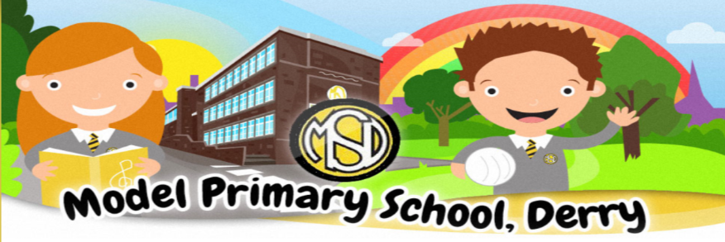

Dear Parents,
I’m sure you are all as bewildered and frustrated about our phased return to school as I am.
We were hoping for a safe return to school for all of our children but as you are aware, we have been advised otherwise.
From 8 March until 19 March, pupils in pre-school, Nursery and P1 to P3 will return to full-time face-to-face teaching. From 22nd March until Thursday, 1st April these classes will return to Remote Learning. I am hoping that good sense will prevail and that these year groups can continue to be taught face to face until Easter. I am not happy with this approach, which is confusing for young children and very inconvenient for parents. Canteen will be open to provide meals for those wishing to avail of them from Nursery to P3. School uniform to be worn.
Nursery and pupils in P1 to P3 including ASC (P1 to P3) will then return to full-time face-to-face teaching after the Easter holidays.
P4 to P7 will continue to be taught remotely and no date has yet been given for their return to face to face teaching.
I appreciate if you have a child at home and a child at school that this is far from an ideal situation.
Please note that from Monday 8th March the use of Remote Learning on Seesaw and Google Classroom will stop except for homework activities. If you choose to keep your child at home without a valid reason we cannot provide work.
“In recognition that any further increase in pupil attendance before mid-April has the potential to impact on the trajectory of the pandemic, the Executive have decided that to enable the return of qualification years, remote learning will resume for pre-school/nursery and pupils in P1-3 for the week beginning 22 March until the planned start of the Easter holidays for individual schools.”
As of yet no date has yet been given for their return to face to face teaching of pupils in P4 to P7.

Keyworker & Vulnerable Pupil Provision will continue as it is now. Please note these children will be engaged in Supervised Learning.
Payment for Free School Meals will continue to be made and these children should bring in a packed lunch. Please send in healthy snacks for your child’s break.
All children will be required to wear their school uniform from Monday,8th March.
Whilst I cannot guarantee a completely Covid19 free school environment, I believe that the procedures that we have put in place were effective in the past and that any spread in our school was extremely low.

Again, I want to thank each and every one of you for your patience and support and for the excellent job that you have done with Home Schooling your children and supporting them through these difficult times.
Dates for your Diary
School Closed Wednesday,17th March (St Patrick’s Day)
Thursday,18th March (Staff Development Day)
Easter Holidays Thursday,1st April (from 12 noon) until Friday, 9th April (inclusive)
Half Term Monday,3rd May to Friday, 7th May
Bank Holiday. Monday,31st May
Confirmation Monday, 19th April
First Communion Wednesday, 26th May at 5pm
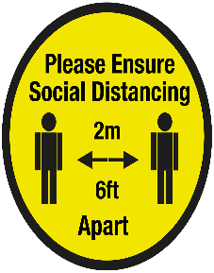
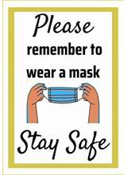
Parents Drop off/Pick up
At usual times as per from September
Please adhere to social distancing & wear a mask.

Digital devices
If you require support with digital devices, please get in touch. We have a number of chrome books available to lend out until we return to school full time.

