We as a school would like your support to show generosity and kindness to those in our local community who are struggling at this time. Not only can we help them to enjoy their Christmas but we can share the gift of love, the true spirit of Christmas.
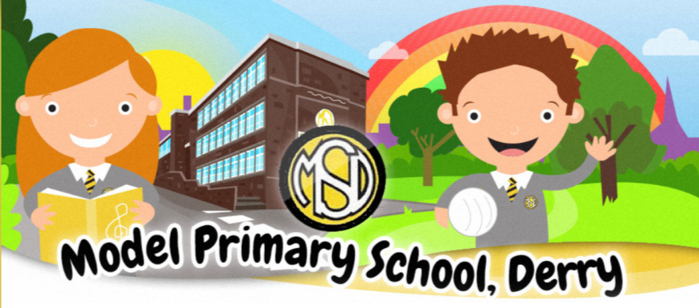
Some families send in gifts for teachers and LSAs at Christmas time. Whilst we appreciate your kindness and generosity we are asking this year again if each class could support a food hamper which will be donated to St Vincent de Paul and the Salvation Army.
Our goal is for each class in our school to work together to fill a Christmas Hamper. If each pupil can make a small contribution, together we can make a HUGE difference. Below is a list of items.
Tea | Coffee | Cooking Oil | Chocolate Orange
Box of Celebrations | Shortbread | Gravy | Dried/Tinned Peas
Christmas Crackers | Yule Log | Tin Foil | Pasta
Washing Up Liquid | Shloer | Mince Pies | Tinned Soup
Selection Box | Savoury Crackers | Chutney | Kitchen Roll
Cranberry Sauce | Paxo Stuffing | Diluted Juice | Box of Biscuits
Custard | Pringles | Christmas Napkins | Tinned Fruit
Red Sauce | Pasta Sauce | Granola | Carton of Fruit Juice

Each pupil will randomly select one item from the ‘Class Hamper’ shopping list which they are then responsible for purchasing and bringing to school.
If you would like to do more……..
You could donate more than the one item for the class hamper you can also:
- Purchase a Food Voucher from a local shop which can be used to buy the fresh ingredients needed for a Christmas Dinner
- Purchase toiletries
- Purchase nappies and baby wipes
- Purchasing washing powder and fabric softener
- Purchase a Voucher for a Toy Shop
We ask that you send all donations and items to school no later than Friday 10th December. The hampers and gifts will be distributed to our local community by local volunteers in partnership with St Vincent de Paul and Salvation Army.
Thank you for your support from all the staff at Model P.S.

