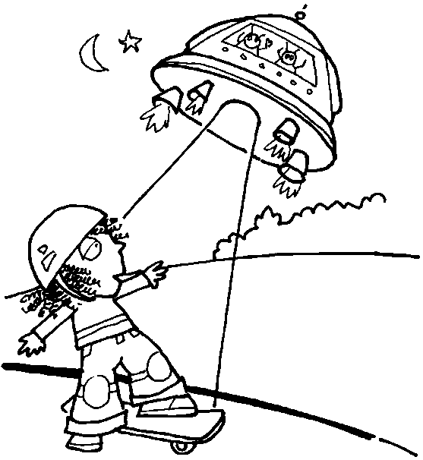

One starry night a girl called Sarah sneaked out of her house on the skateboard she got for her birthday. In a moment she saw a bright light coming from the sky. She felt scared. It was a silver, blue and purple space ship. It was huge. It made a quiet pulsing noise.
A minute later the light started to lift Sarah off the ground. She was wobbling and she was scared “I can’t believe that I can see an alien spaceship,” said Sarah.
Suddenly she was in the spaceship with the aliens. They were pink, purple and blue. They were friendly. One was called Bob and the other was called Twinkle. They said, “Hello, don’t be scared. We are friendly.”
Then she saw some bright, sparkly stars out of the window. She felt so happy and excited. It was a long way to the alien planet and they talked on the journey. Eventually they arrived at the planet Bong. The spaceship landed gently.

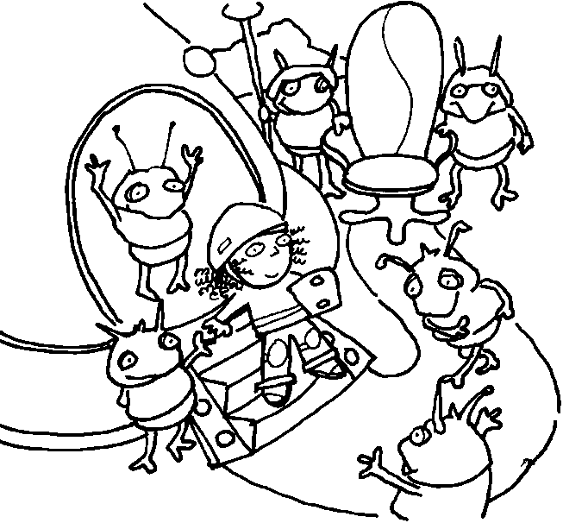

The spaceship door opened and Sarah walked down the steps. She saw lots of aliens. They said, “Hello, thank you for coming here. You are going to be our queen. We have made a lovely golden throne for you and a crown.”
Sarah looked around. The ground was yellow. The sky was orange. It was cold on the planet Bong. She could see earth. Planet Bong smelt like strawberries. It was nice. The aliens asked Sarah to sit down on the throne. They brought her food and drink.

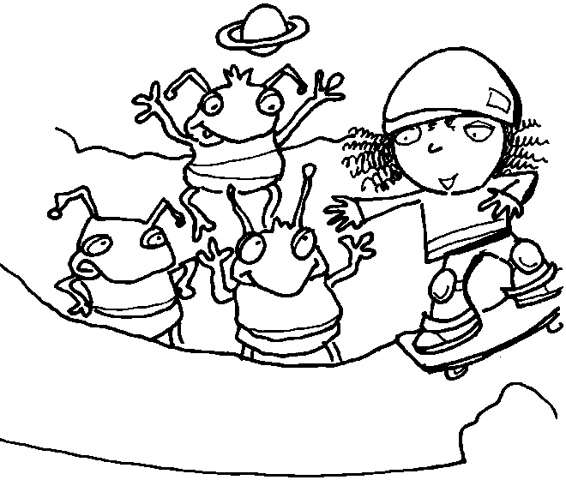

Sarah decided to show the aliens how to skateboard. The aliens asked Sarah to teach them how to skateboard. Bob was waving his hands in the air and shouting “Hurragh!”
An alien called Stephen said, “I could do that easily.”
Then he had a go. He fell off the skateboard. An alien called Hairy said, “Wow! I can do that.”
He grabbed the skateboard and he did it! He was fantastic! All the aliens clapped.

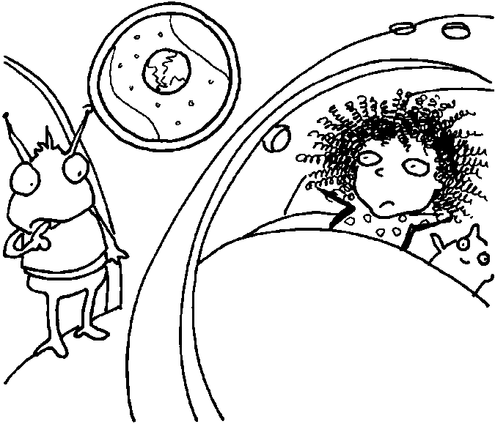

Sarah and Twinkle were in the spaceship’s bedroom. There was a round bunk bed. Sarah had left her skateboard, crown and helmet at the bottom of the bed. Twinkle said to Sarah, “What’s wrong?”
Sarah looked sad. She was looking out the window at planet earth. Sarah said, “I am really sad because I want to go to my real home.”
Twinkle said, “Okay Sarah, I will let you go home.”

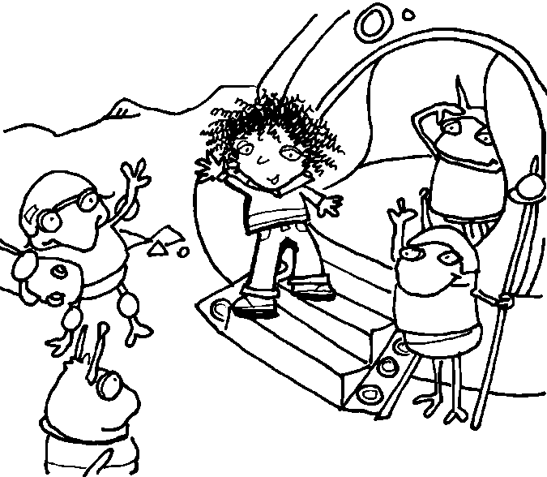

Sarah went back in the spaceship. She gave the aliens her skateboard and helmet as a goodbye present. “We have a gift for you too,” said the alien. “We are giving you our golden crown.”
One of the aliens was crying. Sarah got into the spaceship. The guard said, “Don’t worry, we will get you home safely. You can come back any time you want.

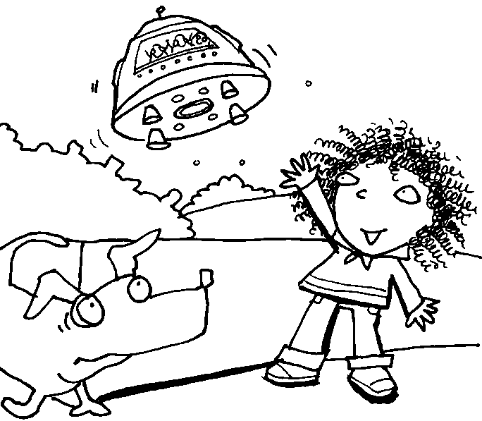

Eventually, Sarah got home to earth. She waved goodbye to the aliens. The aliens went back home after they dropped Sarah off. Sarah was happy because she was home safely. Sarah’s dog was very confused. He didn’t know what was going on. Sarah went home. Her Mummy and Daddy were happy to see her.

The End.

By Sameer, Ben D, Maci, Megan, Ernesta, Padraig and Dean.

