Dear Parents,
Our first week back at school has been very successful. Children are presenting as happy and very pleased to see their teacher and friends. We have worked very hard in our preparations for school return and our routines and procedures have gone smoothly.
As I’ve already stated we will take things slowly to begin. We will do this to ensure that our new normal is firmly established. Children will benefit from time spent on Pastoral Care & Well Being activities daily.
Personally, I am so happy to see our children back where they belong and I will do my best to ensure that all of the school community is kept safe in this uncertain time. We appreciate and thank you for your continued support in implementing safety measures for our children & staff.
Drop off
Children cannot be dropped off until 8:45 as staff will not be available to supervise their bubble before that.
Collection
Please remain in socially distanced spots beside the gate. Once children have been collected please exit the playground as soon as possible.
On Friday afternoons to facilitate a more in-depth clean:
P1, P2 & P3 will finish @ 1:40pm
P4 & P5 will finish @ 1:50pm
P6 & P7 will finish at 2:00pm
This is a decision that we have made in order to ensure the safety of our children & staff.

Absences
We are installing a new telephone system next week where there will be a facility to leave an absence message. Please also state the reason for the absence. As school staff will all be in the playground in the mornings we will not be able to answer the phone.
Please follow the phone instructions

Dinner Money
Please see menu for canteen. The canteen will be offering a limited menu to begin with hot food (burgers, hotdogs) etc. twice weekly. This is a generic menu and will be the same one provided in all schools to begin. The cost is £2.60 daily. As the year proceeds the choices on the menu increase.
Please send money into school in a clearly marked envelope. Children will leave this in a tray in their classroom and this will be delivered to the canteen by school staff. Please note parents do not have access to the canteen to leave money as before.
Canteen lunches will be delivered to the classrooms. This is to ensure that each class bubble is kept as a separate entity as much as is physically possible. Please ensure lunchboxes are sanitised daily.
P.E clothes
For the next while children will not be changing into P.E. clothes for P.E. We ask that you send in a pair of plimsolls/trainers to remain in school in a named bag on their peg.
We understand the value of exercise and want our children to be as active as possible during this recovery period. We will resume our daily “Walk a Mile a Day” and have a mile marked out on our pitch as well as having access to Brooke Park.
Contacting teachers
We ask in the first instance that you contact teachers by email. You can request a telephone call through an email directly to your child’s teacher. Please note face to face meetings are not recommended at present and must pre-arranged with the teacher.
Visitors to the school – including parents/guardians/carers – should NOT enter the school building unless an appointment has been made and confirmed with the teacher in the 1st instance through email or through the school office. All visitors will be required to wear face coverings. They must report to the office and provide contact details for test and trace purposes.
School Building Supervisor
Liam continues to be off on long term sick. We have employed Sean Feeney on a temporary basis as Building Supervisor. We would like to thank Sean and all our cleaning staff for their excellent efforts in getting our school cleaned and ready for return following our Building Works.
Toilets
We are delighted that our toilet refurbishment throughout the school and our new Sensory Room is fully complete. This work has been finished to a very high standard and we are very pleased with the result. We are currently waiting on equipment for our Sensory Room which we hope to have operational soon.

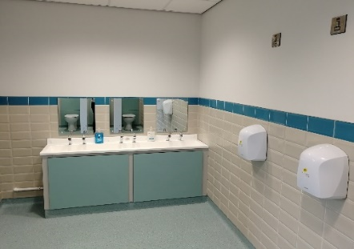
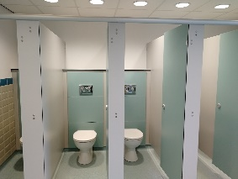

First Communion
Our First Communion will take place on Monday 28th September @ 5pm.
Further details will be sent out to those parents involved.

Homework
We will not begin to give out homework until the week beginning Monday,14th September.
We are currently exploring ways of setting homework as this cannot be sent home in books.

Morning Snack
We can no longer supply fruit to children in schools. Please send in a healthy snack for children at break. Please note we are a nut free school due to children with serious allergies.

