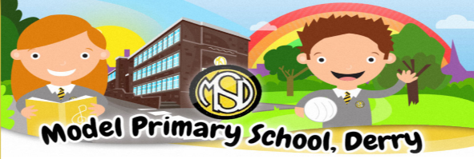
Dear Parents,

Our School Return got off to a great start. Children have adapted quickly to our “new normal “and followed all new school routines with relative ease. It is so heart-warming to see their smiles every morning as they greet me on their way into school.

They are very happy in school and have surprised all the staff with their resilience. Routine is so important for our children as is a sense of belonging to the school community. Children remain safe in their class bubbles throughout the day and are benefiting from time spent outdoors in the mornings playing with their friends, weather permitting of course! We are finding that consequently they come into class well settled and able to concentrate. Spending time outdoors is encouraged as is completing the daily mile.

Our Nursery & P1 children are now well settled in school and it is lovely getting to know them all.

Covid-19
As you are aware, we have had some positive cases in our school community. I’m sure this has left many of you feeling anxious and uncertain. I want to reassure you that we are taking all necessary safety precautions as set out in guidance. We are confident that these cases did not originate in school.

Children are fastidious about hand washing and hands are washed frequently throughout the day. Cleaning of high touch areas, toilets and door handles is carried out continuously.
We have dealt effectively with each case and sought and followed all advice. It is very difficult to have to send a class bubble home to self-isolate and I appreciate the impact that this has on family and working life. Unfortunately, we need to be prepared that this school year will be disrupted until things improve. The most important thing is that our school remains open for the majority of our children.

We have emergency hard copies of work prepared and these will be sent home with the class should they need to self-isolate.
In the case of further lockdown, we will use Google Classroom & Seesaw alongside our existing platforms.

If members of staff are required to self-isolate, this will result in a sub teacher/LSA covering if available. I will do my best to ensure consistency however the demand for sub teachers/LSAs is now very high as every school is in a similar position at present.

Please inform us immediately if your child tests positive as this may result in the class bubble staying at home, depending on last contact with the rest of the class and PHA advice. I can be contacted on mramseymodelps@gmail.com.

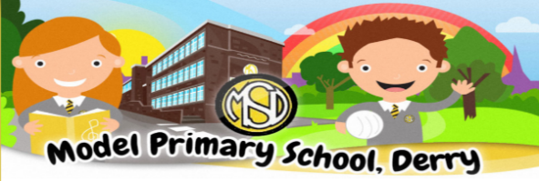
Track & Trace
We are compelled to share contact details with PHA should a case occur in your child’s class.

Free School Meals
If your child is required to self-isolate they are entitled to a free school meals food package.
Please let us know if you would like to avail of this.

School Improvements
We have had a complete boiler refit in September. This had an impact on some of our ageing pipe works resulting in a leak last week. It was with a heavy heart that I had to close for 2 days causing further disruption. This was out of my control and again I appreciate the disruption and inconvenience that this will have caused to you all.

Following a visit to the school by Peter Weir, Education Minister, on 12th August, I want to reassure you all that the Governors and myself are doing our best to ensure that further improvements are planned in the course of the school year including a covered area for Nursery, a refurbished Computer suite and more dry lining of corridors and classrooms. We are also pushing for clarification for long term plans for our school building.

Curriculum
We are concentrating on basics with our children and revision of Literacy & Numeracy skills. Reading is so important, and we ask you to encourage your child to read daily. Teachers spend time on mental Health & Well-Being activities daily.

Maths Week – 10th -18th October. Teachers will be putting emphasis on interactive fun with numeracy using a range of resources. We have also registered the school on the Maths week Ireland website to facilitate this.

Assemblies
As children can no longer meet for our usual assemblies which had been at the heart of school life, we are experimenting with online assemblies. Student of the week has continued using online communication.

Engage Programme As a result of the school restart the Education Minister has allocated means tested funding for all schools across Northern Ireland. As a result, we are exploring the possibility of employing a support teacher until March 2021 for curriculum recovery for all classes.

First communion
Our P5 children celebrated their First Communion on Monday,28th September.
We were delighted that after such a long wait that their special day went ahead.
They were a credit to the school and prepared diligently. I would like to thank Miss McCool and Mrs Devenny for helping the children prepare, Miss Clifford for her wonderful singing and Father Lagan for his support and dedication to the school.

Break the Rules Day This has now become an annual event. On behalf of the PFTA I would like to thank you for your generosity. We raised £600 which will be used for the children’s well-being.

Halloween Break
School will be closed from 26th -30^{th,} October inclusive.

Parent Interviews
Our planned annual parent interviews on Friday ,23rd October have been postponed to a later date. Friday,23rd October will now be a teaching day.

I thank you for your patience, understanding and goodwill as we work together to achieve the best for our children in these very challenging times.

