Dear Parents,

Once again, we are all very happy to be back at school after the Extended Halloween break.
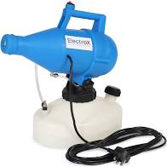
All school staff and the vast majority of our children are back at school from isolation so the break has been beneficial overall in reducing the spread of the virus. With our safety measures in place, the best place for our children is in school.

We have purchased a fogger and each room is sanitised once a week using this device.

Halloween was a disappointing event for our children this year but let’s hope that the sacrifices that were made over the Halloween period will allow us to have a more fun filled Christmas with family and friends.

The children have settled back into routine and are very happy in the school environment, although the cold, damp mornings are a challenge for us all! Behaviour in school has been excellent and we feel that time spent outdoors in the mornings before school and doing our daily mile has contributed to this. Consequently, children settle very quickly to their work once we get into school.

Unfortunately, we are not yet in a position to begin our Breakfast Club or After School activities as we cannot mix our bubbles. This will be reassessed after Christmas and if the overall situation improves we can start to reintroduce some of these activities. I am very aware that the children are missing out on these Extended School activities that we worked so hard to achieve.

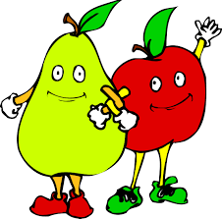
Fruit
From next week we will be providing the children with fruit weekly as we have always done in the past. This will come in separate bags for each class.
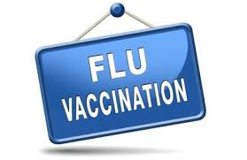
Flu Vaccination
A mop up session of the flu vaccine will take place in school on Wednesday,9th December.
If you have any permission letters at home about the flu vaccine, please return these to school as soon as possible.

Music Tutors
From next week our music tutors will begin tutoring those children in P6 & P7 who have musical instruments. After Christmas we are hoping to get our P5 children tested for instruments, all being well. Music tuition will take place in the Assembly Hall in class bubbles with all safety measures in place.

Canteen
A new canteen menu will be added to the School App and School Website. Next week we will be on week 4.

PE Shoes
We can now resume our indoor PE lessons. For now, can you please send in a pair of PE shoes that can be kept in school.

For the continued safety of our children can you ensure that:

- when you pick up your child in the afternoon that they remain with you and are not running around mixing with children from other bubbles. We take very stringent measures to ensure their safety in their own specific bubble throughout the day. Once we have handed over your child it then becomes your responsibility to ensure that they remain with you. This is becoming hard to manage at present and we need your support to keep the spread of the virus to a minimum.

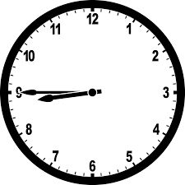
- Children are not dropped off in the mornings until 8:45.
Children are waiting under the canteen and again, mixing with children from other bubbles. Staff are not in attendance until 8:45. Children should be dropped off between 8:45 & 9:00 am as stated in the Return to School Information.

- If anyone in your household is being tested for Coronavirus, then your child must remain at home until the result of the test comes through.
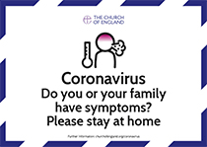

Please adhere to social distancing in the afternoons when picking up your child.

